

# AMERICAN INTERNATIONAL UNIVERSITY-BANGLADESH (AIUB)

Faculty of Engineering

Bachelor of Science in Electrical and Electronic Engineering (EEE) BAE 2101: Computer Aided Design and Drafting

**Experiment # 09:** Understanding and drawing the connection diagram of Switchboard (SB), Sub Distribution Board (SDB) and Main Distribution Board (MDB) based on Civil planning using AutoCAD software**.**

**Objective:** To familiarize students with proper understanding of drawing of Switchboard (SB) Connection Diagram, Sub Distribution Board (SDB) Connection Diagram and Main Distribution Board (MDB) Connection Diagram based on civil planning using AutoCAD software.

# Switchboard (SB) Connection Diagram:

1. This is nothing but a detailed description of load-connectivity under a particular SB.
2. The input for this step is both the fittings and fixture layout as well as the conduit layout. Name of loads are collected from fittings and fixture layout. The wire sizes are collected from conduit layout.
3. Demonstrate each group separately. The grouped switchboards must be interconnected with suitable wires as per the conduit layout. All SB must be connected with ECC (with suitable size).
4. Indicate all the cable sizes in detail along with ECC. Also demonstrate the connection of Group to the SDB.

# Sub Distribution Board (SDB) Connection Diagram:

1. This is the interface between a flat’s connected loads with the external power. This panel holds all the required protective devices for a flat. We can call it as a collection of circuit breaker for a flat.
2. Connect each group of switch board through matched circuit breaker (CB) to the SDB busbar. The 15A loads as well as 20A loads (ACs) should be connected as well through matched CBs.
3. The SDB busbar contains either single phase or 3-phase 4-wire lines depending on the total connected load for the apartment. If the connected load is less or equal to 9KW then the supply should be single phase 240V line to neutral. If it exceeds 9KW but below 48KW then the supply should be three phase 415V line to line. If it exceeds 48KW then three phase 11KV line to line supply is provided which needs a setup of substation.
4. Demonstrate each group separately. The grouped switchboards must be interconnected with suitable wires as per the conduit layout. All SB must be connected with ECC (with suitable size).
5. Indicate all the cable sizes in detail along with ECC. Also demonstrate the connection of Group to the SDB.
6. Divide the loads to each phase separately so that overall balance on the lines is maintained. Try to divide the overall load equally to each phase (i.e. if there are 3 ACs, divide each AC to each phase, don’t connect all of them to one phase).

# Mention your load division among the three phases.

1. Choose the main circuit breaker for the SDB with a consideration of the demand factor. The demand factor depends on many issues. For office it is close to 90% but for household applications it may be 60%-70% (i.e. an apartment near Gulshan is supposed to have much higher load factor than near Mirpur).
2. The type of the main CB is TP (Three pole) and the rating need to be chosen from the current rating table. The size of the ECC should be chosen from the table as well. Also, a matched conduit needs to choose to carry the incoming cable from the MDB.

# Main Distribution Board (MDB) Connection Diagram:

1. This is the interface between the MDB to different SDB of an apartment. It also holds all the metering equipment’s for the apartment.
2. The main incoming line is carried through a 3-phase check meter and the connected to the central busbar. The busbar consists 3-phase 4-wire lines. Then each supply for each SDB is carried from the busbar through meter for the designated flat and matched TP CB which is placed at the flat SDB. This means that two similar CBs are placed at both MDB and SDB to protect the interconnecting line as well.
3. The main CB for the apartment is a TP MCCB (Molded-Case-Circuit-Breaker). It’s rating should be obtained from the current rating table considering the demand factor for the apartment (60% is a typical value).
4. The grounding of the complete apartment is done at MDB. EL is carried to earth from MDB. The size of the conduit to carry the EL should be demonstrated explicitly.

**Sample Drawing:**

**Switch Board Connection Diagram**

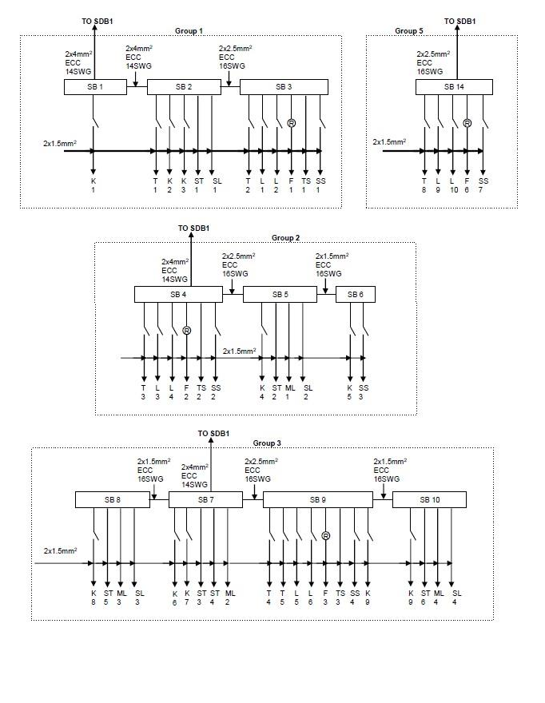

**Switch Board Connection Diagram (contd.)**

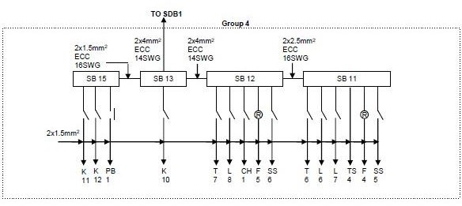

**Flat Distribution Board Connection Diagram**

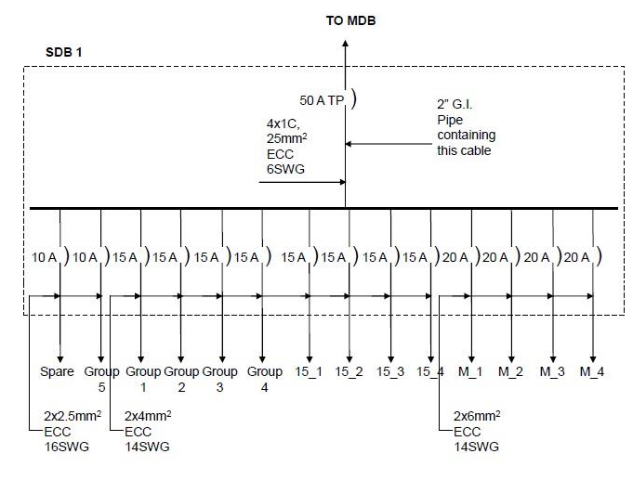

**Main Distribution Board Connection Diagram**

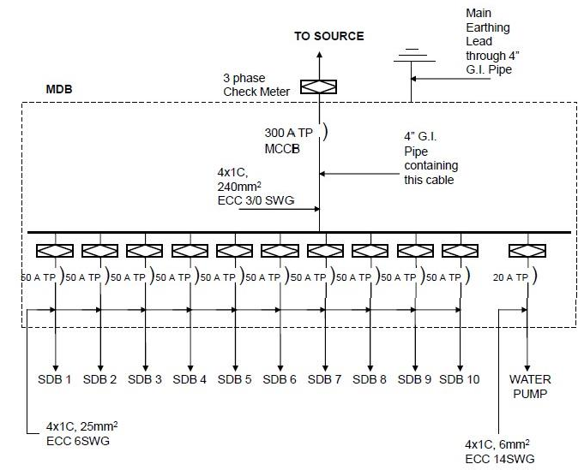

# Pre-Lab Homework:

Student must show any kinds of homework that might be assigned. The homework should be done with AutoCAD software, and must be presented before the start of the experiment.

# Discussion and Conclusion:

Interpret the findings and determine the extent to which the experiment was successful in complying with the goal that was initially set. Discuss any mistake you might have made while conducting the investigation and describe ways the study could have been improved.

# References:

1. Kristen S. Kurland, “AutoCAD 2004, 2D Training Manual”.
2. Bob McFarlane, “Beginning AutoCAD 2004”.
3. David Byrnes and Mark Middlebrook, “AutoCAD 2007 For Dummies”.